

SMA CONNECTORS

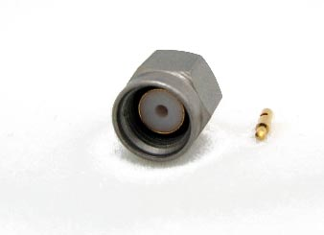
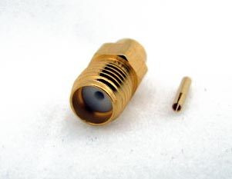

HIGH PERFORMANCE SMA CONNECTORS

Electrical
Impedance | 50 Ohms Nominal
Frequency Range | DC – 18 GHz
Voltage Rating | 500 Volts Peak
D.W.V | 1000 Volts RMS
VSWR | 1.01x.005f (GHz)
Insertion Loss | .03x e f (GHz) dB

Mechanical
Mating Torque | 15 inch pounds
Cable Attachment | Solder
Cable Retention | 60lbs

Materials
Body | Gold Plated or Passivated Stainless Steel
Contact | Gold Plated Beryllium Copper
Insulator | PTFE

Environmental
Temperature Range | -65°F to +165°F
Temperature Cycling | MIL-Std. 202 Method 102 (Test Condition C)
Moisture Resistance | MIL-Std. 202 Method 106 (Test Condition B)
Corrosion | MIL-Std. 202 Method 101 (Test Condition B)
Vibration | MIL-Std. 202 Method 204 (Test Condition D)
Altitude | MIL-Std. 202 Method 105 (Test Condition C)

The SMA series of connectors from Coaxial Precision Assemblies are manufactured to meet the military interface standards defined in MIL-STD 348. These series of connectors are tuned to provide an optimum match when installed on the cable assemblies.

These connectors are available from stock for both .141 and .085 semi rigid cables, including designs for low loss cables.

Please contact the factory or your local representative for price and delivery.

PART NUMBER | CABLE TYPE
2000-0101-02 | 0.141 semi-rigid
2000-0102-02 | 0.141 LL semi-rigid
2000-0103-02 | 0.085 semi-rigid
2000-0104-02 | 0.085 LL semi-rigid

SMA MALE FOR SEMI-RIGID CABLES
SMA FEMALE FOR SEMI-RIGID CABLES
PART NUMBER | CABLE TYPE
2001-0101-01 | 0.141 Semi-rigid
2001-0102-01 | 0.141 LL semi-rigid
2001-0103-01 | 0.085 semi-rigid
2001-0104-01 | 0.085 LL semi-rigid

